Weekly Monitoring Log for Monday, 12/9/19 - Friday, 12/13/19
Quarter 2, Week 9 (Yellow)
Current Learning Goal(s):  TSW be able to describe how the Earth is connected to and affected by other objects in the solar system including its:  - movement,  - relative position to other objects,  - seasons, and  - visible constellations.  TSW be able to describe the relationship between the Earth and the moon (including the  - phases of the moon,  - ocean tides, and  - eclipses). | 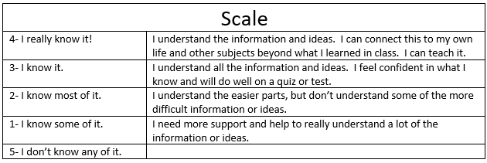
MONDAY:
*Response to Warm-Up Prompt: | *Today I learned/applied/reviewed/demonstrated…  my knowledge of the Sun, constellations, and the Solar System.
*Rate yourself on the Learning Goal & Scale and explain why you gave yourself that score: | *Were you absent today? (yes or no): __________  If so, did you check Mr. Pysher’s webpage at https://www.cusd80.com/Page/76352 to preview what you missed? You can pick up work sheets and note sheets when you return to school.
TUESDAY:
*Response to Warm-Up Prompt: | *Today I learned/applied/reviewed/demonstrated…  even more about the Sun and the Solar System.
*Rate yourself on the Learning Goal & Scale and explain why you gave yourself that score: | *Were you absent today? (yes or no): __________  If so, did you check Mr. Pysher’s webpage at https://www.cusd80.com/Page/76352 to preview what you missed? You can pick up work sheets and note sheets when you return to school.
WEDNESDAY:
*Response to Warm-Up Prompt: | *Today I learned/applied/reviewed/demonstrated…  my knowledge of the Sun, constellations, and the Solar System.
*Rate yourself on the Learning Goal & Scale and explain why you gave yourself that score: | *Were you absent today? (yes or no): __________  If so, did you check Mr. Pysher’s webpage at https://www.cusd80.com/Page/76352 to preview what you missed? You can pick up work sheets and note sheets when you return to school.

THURSDAY:
*Response to Warm-Up Prompt: | *Today I learned/applied/reviewed/demonstrated…  my knowledge of astronomy for the final.
*Rate yourself on the Learning Goal & Scale and explain why you gave yourself that score: | *Were you absent today? (yes or no): __________  If so, did you check Mr. Pysher’s webpage at https://www.cusd80.com/Page/76352 to preview what you missed? You can pick up work sheets and note sheets when you return to school.
FRIDAY:
*Response to Warm-Up Prompt: | *Today I learned/applied/reviewed/demonstrated…  my knowledge of astronomy for the final.
*Rate yourself on the Learning Goal & Scale and explain why you gave yourself that score: | *Were you absent today? (yes or no): __________  If so, did you check Mr. Pysher’s webpage at https://www.cusd80.com/Page/76352 to preview what you missed? You can pick up work sheets and note sheets when you return to school.

*Current Science LETTER Grade:___________

*Summary of what I learned in science this week:

Other information I want Mr. Pysher to know about this week:

*Student Signature:____________________________________ *Date:________________

**Parent Signature:_____________________________________ *Date:________________

